- Authentication APIs

  - AWS Cognito – Sign-Up
Purpose Create a new account and seed the user pool.
Method POST (AWS Cognito SDK / Amplify Auth).
Process Takes email + password → returns JWT + Cognito ID; the app stores that ID locally and in DynamoDB for cross-reference.

Key Code

  - AWS Cognito – Login
Purpose Authenticate existing users.
Method POST (AWS Cognito SDK / Amplify Auth).
Process Email + password → Cognito verifies → returns fresh JWT tokens (ID, Access, Refresh).
Key Code

- AWS Amplify GraphQL
Endpoint | Purpose | Key Code
CreateOnboardingData | Store first-time quiz results ( equipment, fitness type) | await client.models.OnboardingData.create({...})
UpdateOnboardingData | Let returning users tweak their quiz answers | await client.models.OnboardingData.update({...})
ListOnboardingData | Retrieve the logged-in user’s record | await client.models.OnboardingData.list({ filters:{ userID:{ eq:userID }}})

How it works: AWS Amplify automatically generates GraphQL API endpoints to interact with DynamoDB.

- ExerciseDB via RapidAPI

Fetch Exercises by Target Muscle
Purpose Pull a big pool of candidate moves.
Method GET /exercises/target/{muscle} (RapidAPI key in headers).
Key Code 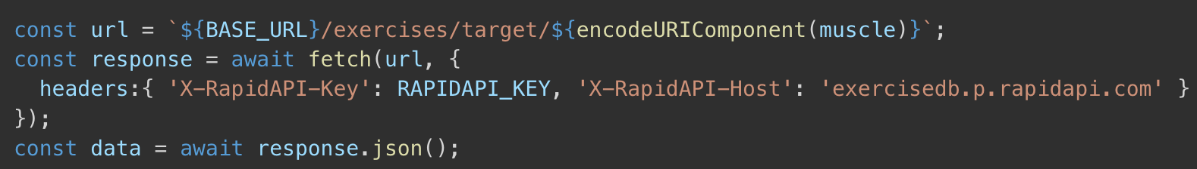

- Nutrition Recommendation APIs (Spooncular)
Fetch Meal Suggestions
Purpose Serve balanced meals that align with the user’s calorie/macronutrient targets.
Method GET /mealplanner/generate (API Key as query param).
Process The app sends targetCalories & diet prefs → receives a JSON list of recipes.
Implementation mirrors the ExerciseDB flow—wrap in fetch(), parse JSON, then store in app state.

